CSC5991 HW1 Wei Zhou

For random local joke hit <http://127.0.0.1:5000/joke/>:

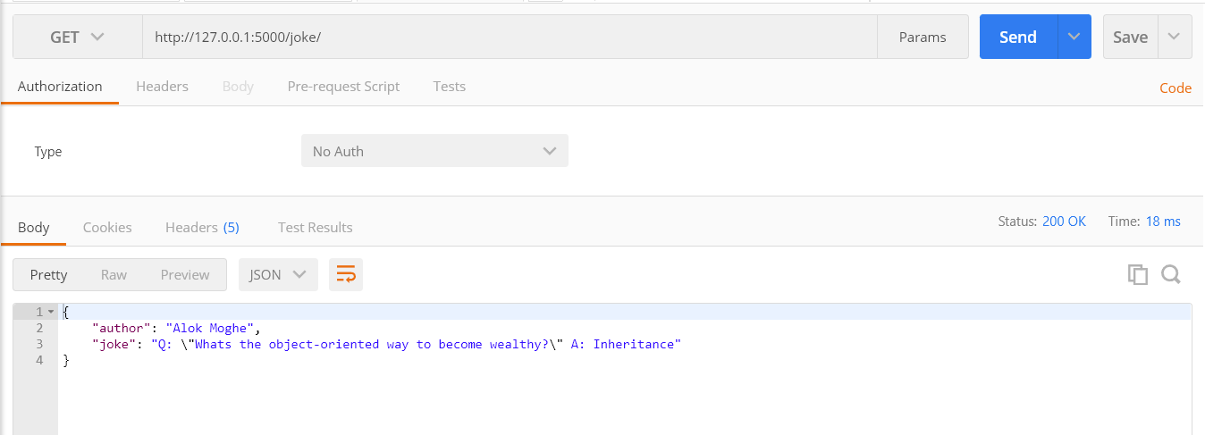

You also can get online jokes by getting jokes form jokeapi hit http://127.0.0.1:5000/online-joke/:

